Title or Task: | Cover Page for Essays  
Description: | A template for writing essays
Files Required | USB Thumb Drive or Network
Suitable for Classes: | All Classes
Area: | Technology & Enterprise
Teacher: | Mr Peter Faulks
Timeline | 1 lesson
Date Due: | 1 hour
Task Brief: | Create your own cover page
Outcomes: | Aprropriate documentation to submit school work in essay format

Items highlighted in yellow are tasks for you to complete
Items in Blue are help tips

TASK Set Up A Cover Page for an essay
Set up a cover page for presentation of a university, school or college essay.

Important tools
Here is a selection of important tools you need to become familiar with in order to complete your work effectively.

Using Headers and Footers
Headers and footers are areas at the top and bottom margins of each page in a document.
You can work in the header and footer areas if you:
• click on View in the toolbar
• select Header and Footer.

On every document you create:
• insert your name as a header
• the name of the piece of work and page number as a footer.

The header and footer will then appear on all pages in that document. There is no need to add one to each page individually.

Spelling and Grammar checks
Regardless of what type of file you have produced on your computer you should always check it for spelling and grammatical errors.
To do this:
• the tool bar
• click on Tools
• select Spelling and Grammar.

A dialogue box should appear identifying items that need changing or you will receive a message telling you that the checking is complete.

Don’t forget though that not all errors are picked up and nothing can replaces careful proofreading.

Using shortcut keys
Shortcut keys allow you to use the keyboard for many tasks rather than using the mouse and the toolbars all the time. You will find lists of keyboard shortcuts by using the Help menu (press the F1 key). Here are just a few to get you started.

Keys to press | What they do
CTRL+B | Make letters bold
CTRL+I | Make letters italic
CTRL+U | Make letters underline
CTRL+C | Copy the selected text or object
CTRL+X | Cut the selected text or object
CTRL+V | Paste text or an object
CTRL+Z | Undo the last action
CTRL+Y | Redo the last action

Print Preview
The print preview tool is very useful so that you can not only view how your work will look before you print it, but it will save you paper and ink by helping you to identify and fix as many mistakes as possible before printing:
• click on File on the menu bar
• select Print Preview
• view your document
• click on Close to return to your document window.

Page Setup
Sometimes you need to change the way your page is orientated to show your work to its best advantage. You can go this by:
• click on File on the menu bar
• select Page Setup
• choose Portrait or Landscape for your page orientation.

Printing
If you have access to a printer you will be able to use the Print tool to make a hardcopy of your work if required. You can access the Print tool by:
• clicking on File
• selecting Print
• choosing your requirements in the dialogue box and
• clicking on Ok.

If you have the standard toolbar visible (by selecting View, Toolbars, Standard) you should be able to see an icon of a printer. This is a shortcut to print but you will not be able to manipulate which part of your document prints or how many copies you can print.

First understand wether you are submitting an Essay, Assignment Task or a Report

Documents available
WKS001 Cover Page Essays.doc (this document)
WKS002 Cover Page Assignments.doc
WKS003 Cover Page Reports.doc
WKS004 Cover Page Referencing.doc
WKS005 Essay Sample.doc

This document includes a sample Cover page that you should modify to your own requirements

An essay is a piece of writing that is written to convince someone of something or to simply inform the reader about a particular topic.
A Cover page should be one page at the beginning of your submission with or without borders and include:

Your name
The title i.e. (Applied Information Technology)
Title of task/assignment (Portfolio cover)
Teacher’s name (Mr Faulks)
The date it was submitted
A marks box
Your logo
Photo of your self with the background erased
No pre-formatted background
Spacing 1.5 lines
A Table of Contents should be included
References or a Bibliography should be included
Credit all material used (Source and or URL)

Included here is are several samples of a cover page for each. A cover page presents your work in a professional manner it is usually worth a percentage of your mark for correctness and appearance.

Simple and complex samples are appended to this document

Cover page for an Essay

Do NOT submit Essays or Reports in A4 Sleeves your document should be stapled three staples left side and be an open document, however you may submit an essay in a document folder but do NOT use sleeved folders for individual pages.

ALWAYS make a back up of you work BEFORE submitting it to print.

I suggest you purchase a Flash Drive specifically for schoolwork of a size that should carry all you work. On the flash drive create a folder with your name. (You would be amazed how many Flash Drives are left in Computer Rooms).

I usually have this folder on all my flash drives as a word document.

Contact Owner
Please contact Peter Faulks
School:
Home Room:
Mobile:
Phone:
E-Mail:

Please respect the contents of this flash drive.

A permanent Pen marking your name on the outside of the flash drive is recommended.

Your cover page sample is next followed by how to set this up…
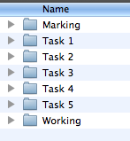

Copy the next two pages and save as a new document
Change headers and footers

Title as yournameTask1.doc or yournameEssay1.doc


Save this document to the appropriate task folder

Unit Title (Class)
Cover Page for an Essay

Teacher - Unit Controller:
Peter J Faulks

ESSAY TITLE

Picture of yourself

Due: Friday 19th May, 2017

Submitted: Monday 15th May, 2017

Length: 665 words (use tools word count)

Topic: The Title of the Essay

Worth: 20%

“I declare that this is my own work and has not been submitted, in part or in whole, for any other unit”
sign here

NAME: Your Name

STUDENT ID: Your ID

Email: youremail@school.wa.edu.au

Teacher Use Only
Comment | Mark:

An Essay requires: Certain content (Thesis = topic)

Introduction,
The first paragraph of essay, offers background information and includes thesis (topic) statement, it should contain an attention grabber for the reader or at least make the essay sound interesting, may begin with a quote about the particular topic. It may also include which side you wish to support (usually as the last statement in the introduction).

Body
Usually restates the thesis (topic) as a proposition, advanced as an argument
usually about three paragraphs long, and offers support and examples for thesis (topic) statement in some sequential order. Sometimes you can offer alternative arguments and suggest reasons why you do not support these arguments.

The first sentence of each body paragraph, connects to the thesis (topic) and outlines that paragraph to supporting sentences – all other sentences offer examples and support for topic with consideration to your opinion.

Conclusion
Restates (not repeats!) thesis (topic) and offers closing statement that leaves reader with final thought, usually better if this is your personal take on the topic.

Include references
References or a Bibliography should be included

Footer
Your Name Class & Tile of essay Page & Numbers
For the front (cover) page this should be set up without header or footer
From File Page Set Up Click on Layout tick different first page
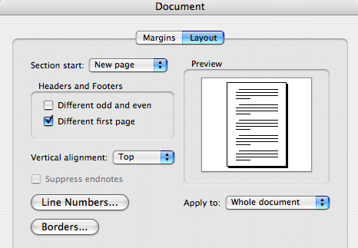
- On the header put your name class and subject or title
Ima Goodkid Y11 Digital Media How To Write A Report

- On the footer type Page ? (insert) of ?? (insert no pages)

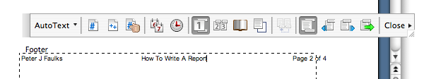

- Your report typed as 1.5 line spacing
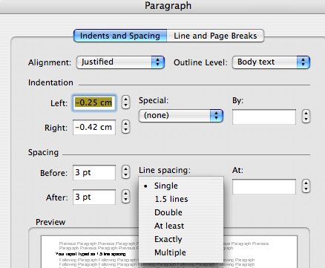

Page set up should be as follows: Left Margin 3 cm Right Margin 2 or 3 cm you may also mirror margins if submitting a stapled document.
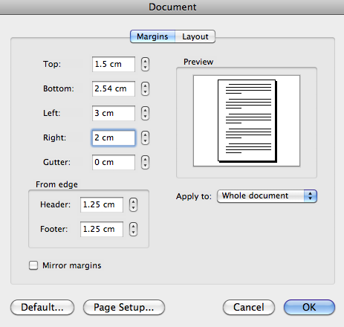

Insert a Table of Contents
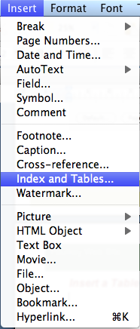

- Place the insert point after your single cover page
- Mark all your headings as Heading 1
- Sub Headings as Heading 2 etc.
- Then Insert Index & Tables
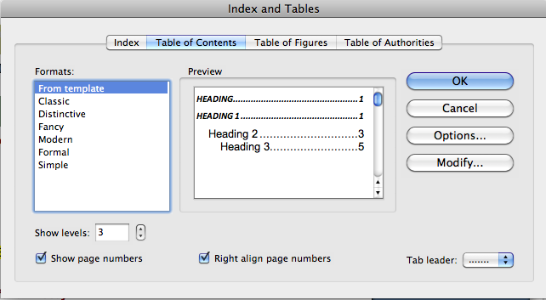
You can replace this as tou

COVER PAGE Sample follows - MODIFY TO SUIT ADD Images to enhance

How to Reference

Types of Bibliography
Peter J Faulks is author of a 300 page book and several booklets and manuals…
The easy way is to copy a reference that suits your source and change it to suit your source information.
i.e. copy this for a book then change the details

Bellito, Christopher M., (2008) “101 Questions & Answers on Popes and the Papacy”, New York, Papac, Paulist Press.

Types of Bibliography

Book (Single Author)
This is how I do it : (Baxter etc… not in bold text though) - you can change it to how you think it should read!

Author Surname, Initial. (Year). Title. Place of Publication: Publisher.

Bellito, Christopher M., (2008) “101 Questions & Answers on Popes and the Papacy”, New York, Papac, Paulist Press.

You don’t need to put the title in inverted commas – I do though…

Baxter, C. (1997). Race equality in health care and education. Philadelphia: Ballière Tindall.

Book (Multiple Author) (Standard reference type)
Author Surname, Initial and Author Surname, Initial. (Year). Title. Place of Publication: Publisher.

Burns, Nancy and Grove, Susan K. (1997) The practice of nursing research: conduct, critique & utilization. 3rd edition. London, Saunders.

Magazine or Newspaper Article
Author Surname, Initial. (Date). Title. Place of Publication, Page Numbers.

Greenberg, G. (2001, August 13). As good as dead: Is there really such a thing as brain death? New Yorker, 36-41.
Online Document including Web Page
Author/editor surname, Initial. (Year) Title [online].Edition. Place of publication, Publisher. Available from: URL [Accessed date]

Marieb.E. (2000) Essentials of Human anatomy and Physiology: AWL Companion Web Site.[online]. 6th edition. San Francisco, Benjamin Cummings. Available from: http://occ.awlonline.com/bookbind/pubbooks/marieb-essentials/
[Accessed 4th July 2001].

Other forms of Referencing

Book (Single Author)
Author Surname, Initial. (Year). Title. Place of Publication: Publisher.

Baxter, C. (1997). Race equality in health care and education. Philadelphia: Ballière Tindall.

Book (Multiple Author)
Author Surname, Initial and Author Surname, Initial. (Year). Title. Place of Publication: Publisher.
Burns, Nancy and Grove, Susan K. (1997) The practice of nursing research: conduct, critique & utilization. 3rd edition. London, Saunders.

Magazine or Newspaper Article
Author Surname, Initial. (Date). Title. Place of Publication, Page Numbers.
Greenberg, G. (2001, August 13). As good as dead: Is there really such a thing as brain death? New Yorker, 36-41.

Online Document including Web Page
Author/editor surname, Initial. (Year) Title [online].Edition. Place of publication, Publisher. Available from: URL [Accessed date]
Marieb.E. (2000) Essentials of Human anatomy and Physiology: AWL Companion Web Site.[online]. 6th edition. San Francisco, Benjamin Cummings. Available from: http://occ.awlonline.com/bookbind/pubbooks/marieb-essentials/
[Accessed 4th July 2001].

The Reference Section
The last section outlined how to cite or reference sources within the text. This section shows how to complete the reference section at the end of the essay. The reference section is the list of all the sources cited or referenced in the essay,and only those that were referenced or cited in the essay. The list is arranged alphabetically by the first author's surname. There is a format for listing different types of sources such as books, journal articles and web sources. These are set by the APA and there are numerous sources on the Web that outline the guidelines, for example Nuts and Bolts of College Writing which describes the different formats and also gives more advice on referencing within the essay text. In order to give you some idea how to format the most common sources, the APA format for each one is given below (note: these are taken from the Report Writing Guide but copied here to save download time).

Journal Article
When listing a journal article, you must give the name of the author(s), the year it was published, the title of the actual journal article, then in italics (or underlined) the name of the journal and volume number, and lastly the pages the articles is on. An example clarifies this:
Tudge, J.R.H.,¹ (1989)². When collaboration leads to regression: some negative consequences of socio-cognitive conflict³.European Journal Of Social Psychology⁴ 19,⁵123-138⁶
1. The author(s) name(s)
2. The year of publication
3. The title of the article
4. The journal's name (note italics)
5. The volume number of the Journal (again note italics)
6. The articles page numbers
If there is more that one author, merely give the authors' names in the order they are on the article:
Tudge, J.R.H.,and Winterhoff, P.A.(1989) etc...
Or for more than two authors:
Tudge, J.R.H., Winterhoff, P.A. and Hogan, D.M.(1996) etc..

References layout samples…

Barraclough, Geoffrey, (1968) “The Medieval Papacy”, Thames & Hudson, Norwich.

Bellito, Christopher M., (2008) “101 Questions & Answers on Popes and the Papacy”, New York, Papac, Paulist Press.

Bliss Frederick, (2008) “Anglicans in Rome A History”, Canterbury Press, London.

Libreria Editrice Vaticana (2005) “Compendium of the Catechism of The Catholic Church”, St Pauls Publications, McPhersons Printing Group, Sydney

Norman, Edward, (1985) “Roman Catholicism in England”, Oxford University Press, Oxford.

Seale Mark, (2005) “Liturgy Made Simple”, The Liturgical Press, Collegville, Minnesota

Quinn, John R, (199) “The Reform of the Papacy, The costly call to Christian unity Crossroad”, Publishing House, New York, 1999, p45

Books
The format for books is a little different. The author(s) name(s) come first, then in italics the title of the Book, then where the book was published, and who it was published by:
Piaget, J.¹ (1928)². Judgement and reasoning in the child³.London⁴:Routledge and Kegan Paul⁵.
1. The Author(s) name(s)
2. The year of publication
3. The title of the book
4. Where the book was published
5. The publishers
i.e.
Bellito, Christopher M., (2008) “101 Questions & Answers on Popes and the Papacy”, New York, Papac, Paulist Press.

If the book you are listing is an edited book, then you merely put the editors name where the authors' names are normally put, and put (Eds) before the year of publication. If there is more than one author or editor then follow the format for authors outlined for journal articles.

Chapters in an Edited Book
The format is similar to the book format; first the names of the authors of the chapter, the title of the chapter, the name of the editors of the whole book, the title of the Book (in italics),and finally the place of publication and the publisher:
Glachan, M., and Light,P.¹(1982)²Peer interaction and learning³. In G. Butterworth and P. Light (Eds) ⁴ Social Cognition⁵ Brighton: Harvester.⁶
1. The authors of the chapter
2. The year of publication
3. The title of the chapter
4. The editors of the book the chapter was in, (note the initials come before the surname)
5. The title of the book
6. The place of publication and publisher

Electronic Sources
Electronic sources refer to sources that have been found or retrieved through computer. These can be CD-Roms, telnet sites, or Web pages. The format for most types of electronic source can be found at the APA's own site. The example provided here is of a web-page which is the most common used type of electronic source. It is important to note that the APA make a distinction between citing a whole web site and citing individual pages within a web site. If you cite a whole web site then you merely need to give the URL (the web address) within the text and no corresponding entry in the reference section is needed.
If you are citing a page within a site then a entry within the reference section is needed:
Memory and dementia (1998)¹. London: The Royal College of Psychiatrists². Retrieved January 25, 1996³, from the World Wide Web: http://www.rcpsych.ac.uk/public/help/memory/memory.htm⁴
1. The title of the page and date of publication
2. What organisation was responsible for the page
3. When you looked at the page
4. The URL or web address
If the page has an obvious author, his/her name goes before the title in the manner of a Journal Article. If you have any problems with reference formatting then check out the websites included on the Links page within the Report Writing Guide. The next page outlines a few of the errors made by students in referencing a text.

http://www.psy.gla.ac.uk/~paul/tutorials/essay/essrefer.htm
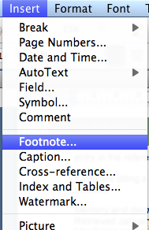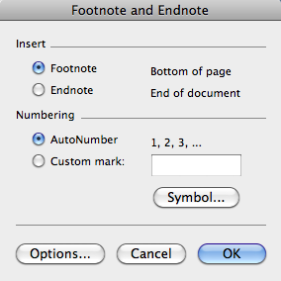

How to insert Footnotes
Copy the reference first then insert your footnote – paste in the reference after the small number at the bottom of your page.

Printed Resources
How to footnote a book:
¹ Ronald Takaki, Iron Cages: Race and Culture in 19th-Century America (New York: Oxford University Press, 1990), p. 113.
or:
² Ronald Takaki, Iron Cages: Race and Culture in 19th-Century America (New York: Oxford University Press, 1990), p. 113.
When the book is edited:
³ Edward Chiera, They Wrote on Clay, ed. George C. Cameron (Chicago: University of Chicago Press, 1938), p. 42.
How to footnote an essay in a journal:
⁴ Samuel M. Thompson, "The Authority of Law," Ethics 75 (October 1964): 16-24.
How to footnote an article in a newspaper:
⁵ "Amazing Amazon Region," New York Times, 12 January 1969, sec. 4, p. E11.

Non-Printed Media
How to footnote a radio or television program:
⁶ TVNZ, "The Amazing Mollusc," 17 April 1972.
How to footnote a film:
⁷ Lee Tamahori, Director, Once Were Warriors, 1995.
How to footnote a recording (in this case, a song called "Blood Red River," on an album called The Legendary Peg Leg Howell:
⁸ Peg Leg Howell, "Blood Red River," The Legendary Peg Leg Howell, 1943, Testament T-2204.
How to footnote a work of art (in this case, a painting):
⁹ Larry Calcagno, Landscape, 1970.

Archival and Documentary Resources
How to footnote a document in an archive:
¹⁰ Gen. Joseph C. Castner, "Report to the War Department, 17 January 1927," Modern Military Records Division, Record Group 94, National Archives, Washington, D.C.
¹¹ Stanley K. Hornbeck, Memorandum on Clarence Gauss, 8 May 1942, Hornbeck Papers, File "Gauss," Hoover Library, Stanford, California.
How to footnote an entire collection in an archive:
¹² Washington, D.C., National Archives, Modern Military Records Division, Record Group 94.
How to footnote a letter written to you:
¹³ John Blank, personal letter, 12 February 1994.
How to footnote a letter that is not in an archive:
¹⁴ Alan Cranston, California State Controller, to Maurice Sexton, Sacramento, 22 October 1962, Personal Files of Maurice Sexton, Modesto, California.
How to footnote a document not in an archive:
¹⁵ Morristown (Kansas) Orphan's Home, Minutes of Meetings of the Board of Managers, Meeting of 6 May 1930.
¹⁶ Sidney E. Mead, "Some Eternal Greatness," sermon preached at the Rockefeller Chapel, University of Chicago, 31 July 1960.
How to footnote a dissertation:
¹⁷ O. C. Phillips, Jr., "The Influence of Ovid on Lucan's Bellum civile" (Ph.D. dissertation, University of Chicago, 1962), p. 14.
How to footnote an interview:
¹⁸ A. A. Wyler, interview held during meeting of the American Astronomical Society, Pasadena, California, June 1964.

Textual Footnotes
How to add a textual footnote (explaining something in the text):
¹⁹ Detailed evidence of the great increase in the array of goods and services bought as income increases is shown in S. J. Prais and H. S. Houthaker, The Analysis of Family Budgets (Cambridge: Cambridge University Press, 1955), table 5, p. 52.
²⁰ Ernst Cassirer takes important notice of this in Language and Myth (pp. 59-62), and offers a searching analysis of man's regard for things on which his power of inspirited action may crucially depend. [Since the work has already been cited in full form, page reference only is required.]
²¹ In 1962 the premium income received by all voluntary health insurance organizations in the United States was $9.3 billion, while the benefits paid out were $7.1 billion. Health Insurance Institute, Source Book of Health Insurance Data (New York: The Institute, 1963), pp. 36, 46.
²² Professor D. T. Suzuki brings this out with great clarity in his discussion of "Stopping" and "no-mindedness"; see, e.g., his chapter entitled "Swordsmanship" in Zen Buddhism and Its Influence on Japanese Culture (Kyoto: Eastern Buddhist Society, 1938).

Online Resources
How to footnote a Web page:
²³ Jim Zwick, Anti-Imperialism in the United States, 1898-1935, http://www.rochester.ican.net/~fjzwick/ail98-35.html (May 1997).

For further reference, see:
C. Lavender's "How to Cite, Bibliography: Using the Chicago Manual of Style," http://www.library.csi.cuny.edu/dept/history/lavender/footnote.html.
The Chicago Manual of Style or Kate L. Turabian, A Manual for Writers of Term Papers, Theses, and Dissertations.
The Sarah Bird Askew Library of the William Paterson College of New Jersey's "Guide for Citing Electronic Information" (www.wilpaterson.edu/wpcpages/library/citing.htm), a version of Li and Crane's "Bibliographic Formats for Citing Electronic Information" (www.uvm.edu/~ncrane/estyles/)
Maurice Crouse's "Citing Electronic Information in History Papers" (www.people.memphis.edu/~mcrouse/elcite.html)
Janice R. Walker's "MLA-Style Citations of Electronic Sources" (www.cas.usf.edu/english/walker/mla.html), endorsed by the Alliance for Computers & Writing
Mark Wainwright's "Citation style for Internet sources" (http://www.cl.cam.ac.uk/users/maw13/citation.html)

Reference
http://www.library.csi.cuny.edu/dept/history/lavender/footnote.html

Samples follow

A Cover Page for all correspondence and reports (with your name and title of document on it) – see sample


1. Cover Page

Cover Page Sample (make yours as exciting as possible)

Presentation by
Picture of yourself (Optional)
Your name

Presentation for

TTT Travel

Title of the topic
"The Impact (positive and negative)
of communications technologies on the travel business."

Student Name:

Signature: I ________________________ advise that this work submitted is my own work and has not been copied or reproduced without reference to the appropriate author, (submission of this essay electronically assumes signature)

Student Number:

Mark/Grade

Comment:

Kilimanjaro coffee company
2008
KCC Annual Report
Africaroma Hit’s Aussie shores
Tim Cartwright
9 fuli st cape town

Student Name: Tim Cartwright

Signature: I ________________________ advise that this work submitted is my own work and has not been copied or reproduced without reference to the appropriate author, (submission of this essay electronically assumes signature)

Student Number: 828500H

Mark/Grade

Comment:
Picture of yourself (Optional)

